Template Social Media Posts
Click here for the Canva template
Click here for United Way of the Columbia-Willamette’s Photo Kit
GENERIC
POST A
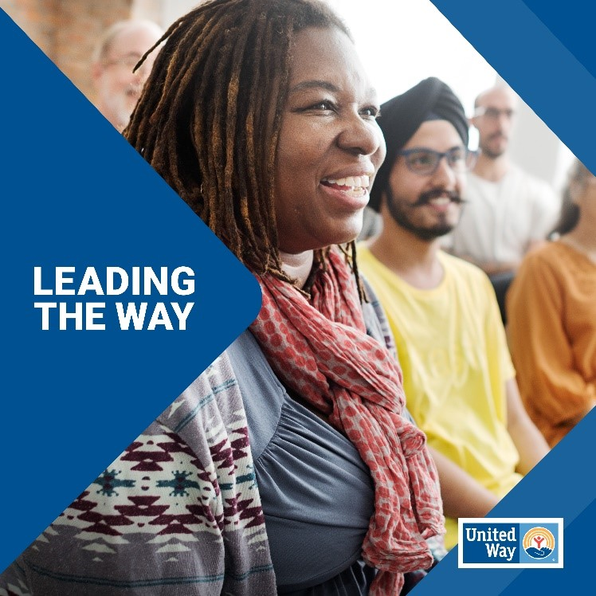
[FB, LI, TH] Join us in #LeadingTheWay to a brighter future in Portland and Southwest Washington! United Way of the Columbia-Willamette mobilizes the caring power of neighbors, businesses, and community partners to strengthen our communities by supporting the needs of our neighbors Your donation can make a real difference. [Hyperlink]
[IG] Join us in #LeadingTheWay to a brighter future in Portland and Southwest Washington! United Way of the Columbia-Willamette mobilizes the caring power of neighbors, businesses, and community partners to strengthen our community.
Click the link in our bio to donate and make a real difference in our community.
[Place the link provided by your UWCW contact in you IG bio or in the Hyperlink space above.]

POST B
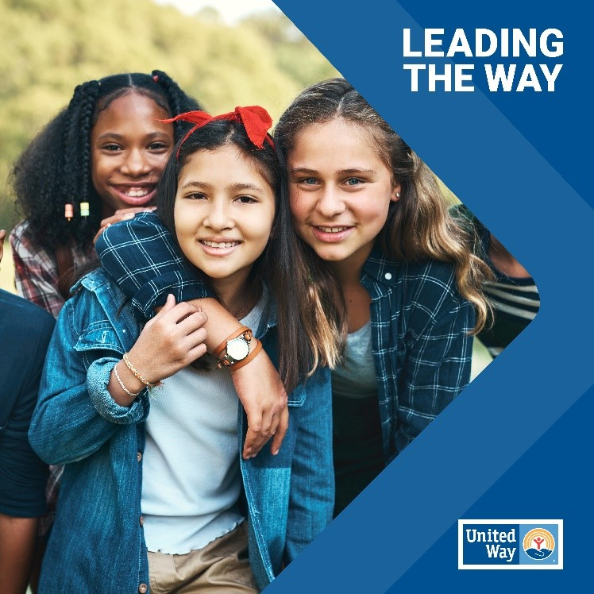

[FB, LI, TH] United Way is #LeadingTheWay in Portland and Southwest Washington by creating a future where everyone can thrive. From strengthening communities to advancing opportunities, we're making it happen. Donate now to be a part of this journey. [Hyperlink]
[IG] United Way is #LeadingTheWay in Portland and Southwest Washington by creating a future where everyone can thrive. From strengthening communities to advancing opportunities, we're making it happen.
Click the link in our bio to donate and become part of this journey.
[Place the link provided by your UWCW contact in you IG bio or in the Hyperlink space above.]

IMPACT AREA: HEALTH
POST A
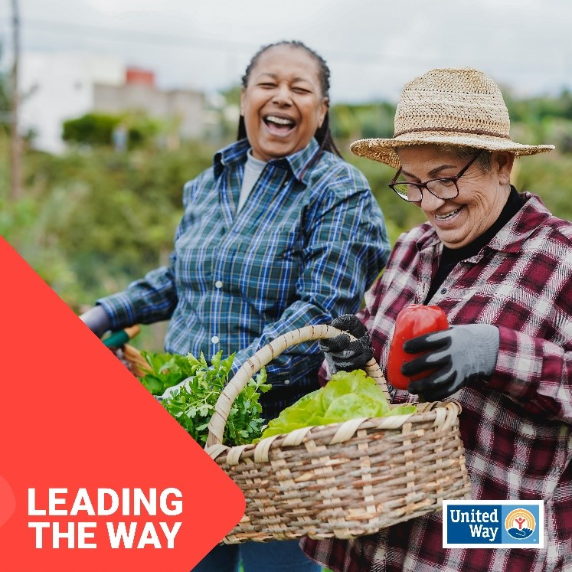

[FB, LI, TH] Together, we can lead the way to create a healthy foundation for everyone in our community. Join us in supporting initiatives like our rental assistance and eviction legal defense program that help all our neighbors in Portland and Southwest Washington thrive. Donate today: [Hyperlink] #LeadingTheWay
[IG] Together, we can lead the way to create a healthy foundation for everyone in our community. Join us in supporting initiatives like our rental assistance and eviction legal defense program that help all our neighbors in Portland and Southwest Washington thrive.
Donate today by clicking the link in our bio. #LeadingTheWay
[Place the link provided by your UWCW contact in you IG bio or in the Hyperlink space above.]

POST B
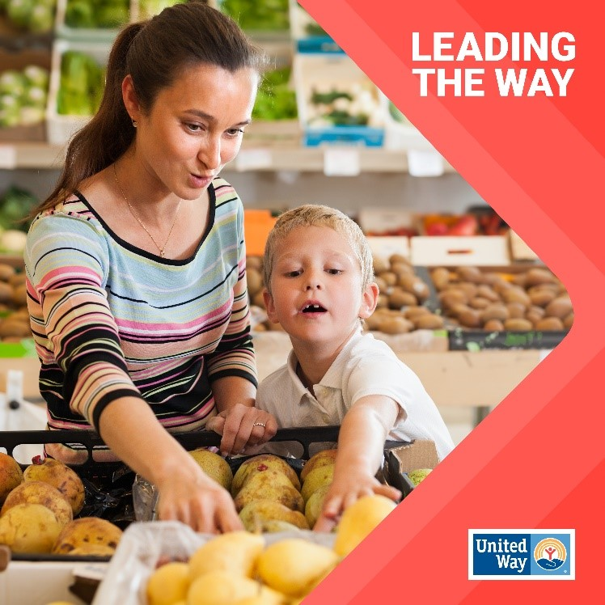
[FB, LI, TH] United Way of the Columbia-Willamette is #LeadingTheWay towards a healthier future for all. In the U.S., 27.6 million people lack health insurance, hindering access to vital care. Let's work together to break barriers to health so everyone in Portland and Southwest Washington can thrive. [Hyperlink]
[IG] United Way of the Columbia-Willamette is #LeadingTheWay towards a healthier future. In the U.S., 27.6 million people lack health insurance, hindering access to vital care. Let's work together to break barriers to health so everyone in Portland and Southwest Washington can thrive.
Click the link in our bio to donate today!
[Place the link provided by your UWCW contact in you IG bio or in the Hyperlink space above.]

IMPACT AREA: EDUCATION
POST A
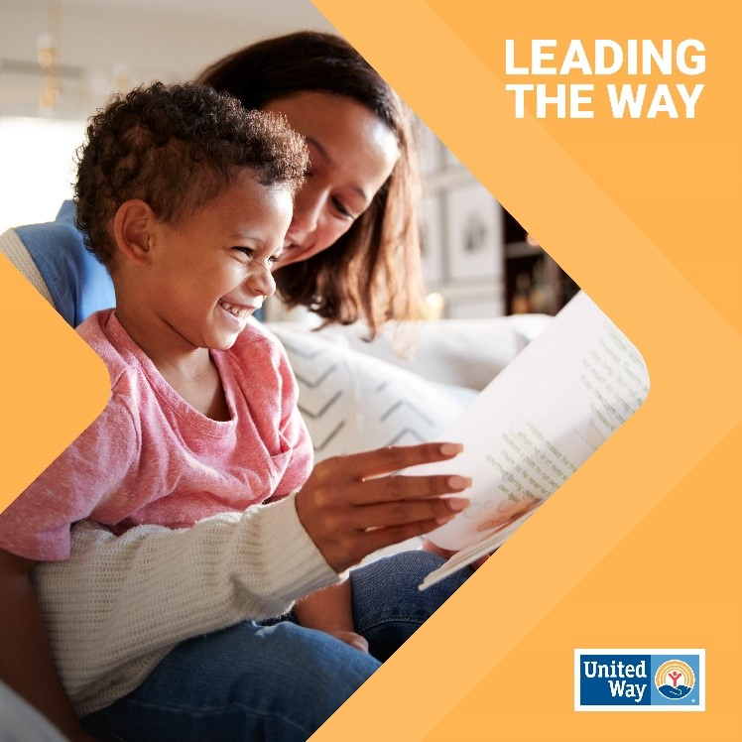
[FB, LI, TH] Did you know that 90% of a child's brain develops in the first five years of life? That’s why we partner with early childhood programs such as STEAM Kids Wonderland program to set kids in Washington County up for success in STEM fields. Let's lead the way in ensuring every child receives a quality education. Donate today: [Hyperlink] #LeadingTheWay

[IG] Did you know that 90% of a child's brain develops in the first five years of life? That’s why we partner with early childhood programs such as STEAM Kids Wonderland program to set kids in Washington County up for success in STEM fields! Let's lead the way in ensuring every child receives a quality education.
Donate today by clicking the link in our bio
#LeadingTheWay
[Place the link provided by your UWCW contact in you IG bio or in the Hyperlink space above.]

POST B
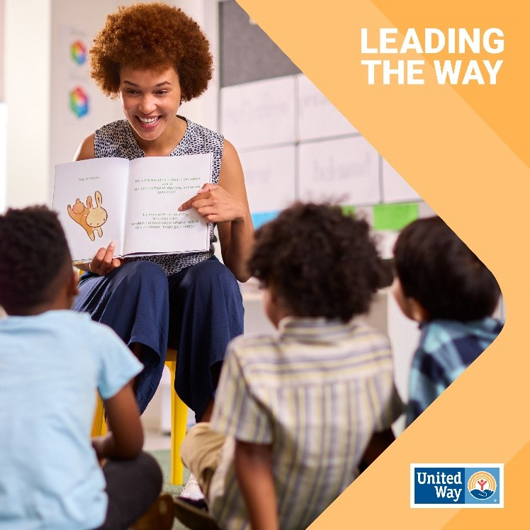

[FB, LI, TH] Education lays the foundation for a brighter future. Sadly, many children face challenges in reading proficiency that affect their academic journey. Join us in #LeadingTheWay towards better education outcomes for all children. Donate today: [Hyperlink]

[IG] Education lays the foundation for a brighter future. Sadly, many children face challenges in reading proficiency that affect their academic journey. Join us in #LeadingTheWay towards better education outcomes for all children.
Donate today by clicking the link in our bio.
[Place the link provided by your UWCW contact in you IG bio or in the Hyperlink space above.]

