Donor Email Templates
Below is customizable text and copy for eight donor emails, with banner images sized accordingly. Here is an overview of what is included:
- Welcome
  - 1a. Workplace campaign kickoff
  - 1b. Company CEO welcome
- Why United Way?
  - 2: Our value-add
- Reminders
  - 3a. Impact
  - 3b. Great things we do together
  - 3c. Time is running out!
- Thank You (post- campaign)
  - 4a. General thank you to all employees, with campaign stats.
  - 4b. Thank you to donors, with review of United Way impact. This can bridge the individual engagement theme (Live Your Purpose) and tee up additional engagement opportunities.

Email 1a: Campaign Welcome and Kick-Off

From: Campaign Chair’s first and last name
Audience: All company employees
Call to Action: Give now to join the campaign
Image: Use below, select one of your own images, select an image from the United Way of the Columbia-Willamette Campaign Photo Kit.
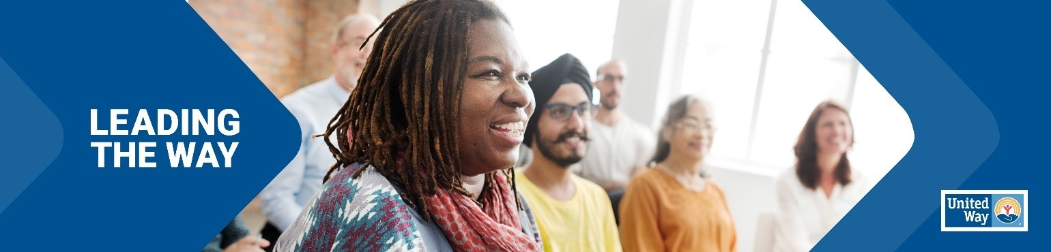
Click here for the Canva template

Subject Line: Leading the Way in Portland and Southwest Washington
Preheader Text: In our community, everyone deserves the opportunity to thrive.
Email Body:
[Name],
Join [Company Name] in leading the way for a better future for all by donating today.
Your support of United Way of the Columbia-Willamette, will allow us to advance health, youth opportunity and financial security to ensure our neighbors can thrive. Our work is powered by generous supporters, like you and [Company Name], who are committed to #LeadingTheWay to a stronger community.
Because of your generous support, United Way of the Columbia-Willamette is making a difference in the lives of thousands of people every year. We need you with us. Donate today and join us in Leading the Way to a better future for all.
BUTTON TEXT: LEAD THE WAY [if your campaign uses online giving, place the link provided by your UWCW contact here]
Closing,
Signature
Email 1b: Company CEO variation
From: Company CEO, Leader, or Employee Campaign Chair’s first and last name
Audience: All company employees
Call to Action: Give now to join the campaign
Image: Use below, select one of your own images, select an image from the United Way of the Columbia-Willamette Campaign Photo Kit.

Click here for the Canva template
Subject Line: [Company Name] is Leading the Way in Portland and Southwest Washington
Preheader Text: In our community, everyone deserves the opportunity to thrive.
Email Body:
[Name],
United Way of the Columbia-Willamette supports the needs of our community every day to help strengthen our community to ensure everyone will thrive. Join me in leading the way for our community by participating in this year’s campaign. We’ve set an ambitious goal of raising [monetary goal/description] to help do just that.
I believe that when we come together as a team, there’s no challenge that can’t be solved. That’s why I’m inviting you to join me in Leading the Way toward positive change in Clackamas, Clark, Multnomah and Washington counties. This is more than a campaign – it is a call to action for us at [Company Name] to advance solutions to real problems facing people in the communities where we live and work.
Together, we can advance health, youth opportunity, financial security and strengthen overall community resilience to build a future where everyone can reach their full potential. We’re counting on generous people like you and your teammates to help improve the lives of people in our communities. Last year, United Way of the Columbia-Willamette was able to provide over $2.5 million to houses on the edge of eviction, ensuring they could stabilize. And this year, with your help, we know that we can do even more.
BUTTON TEXT: LEAD THE WAY [if your campaign uses online giving, place the link provided by your UWCW contact here]
I want to thank you in advance for your valuable support and for Leading the Way here at [Company Name].
[Closing],
Signature

Email 2:
From: Your United Way CEO/CPO, Board or Campaign Chair’s first and last name
Audience: All company employees
Call to Action: There’s still time to give now and join the campaign
Image: Use below, select one of your own images, select an image from the United Way of the Columbia-Willamette Campaign Photo Kit.
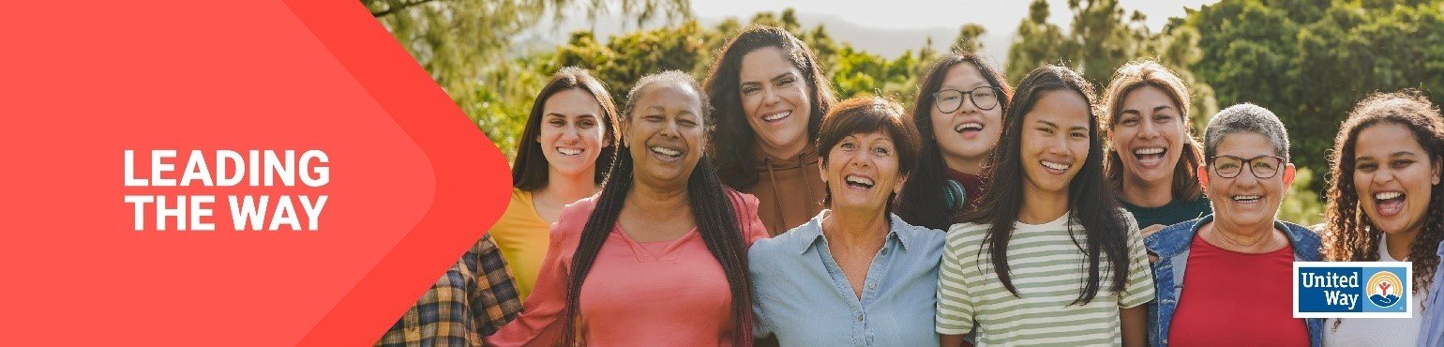
Click here for the Canva template
Subject Line: Lead the Way in Portland and Southwest Washington
Preheader Text: What makes United Way of the Columbia-Willamette so special?

Email Body:

Dear [First name],
United Way of the Columbia-Willamette mobilizes communities to action so that all can thrive. Whenever there’s a need in our community, United Way is there. United Way of the Columbia-Willamette is all about creating a future where everyone, everywhere can rise. And thanks to people like you, we positively impacted thousands of people last year alone.
And we’re not stopping there. Your support can help continue tackling the biggest problems in Clackamas, Clark, Multnomah and Washington counties. From education and health to housing and natural disasters, we bring a comprehensive approach to every challenge. Because more than 100 years of experience has shown us that when people unite to take action, change is possible.
Donate today. Join us in Leading the Way to a better future for all.
BUTTON TEXT: LEAD THE WAY [[if your campaign uses online giving, place the link provided by your UWCW contact here]
[Closing],
Signature

Reminder Emails
Depending on the length of your campaign, we recommend sending one reminder email per week. Below are three sample emails, which can be customized to your United Way, and your relationship with that workplace.
- 3a. Impact. We’ve offered one email with several opportunities to talk about your impact, but you can make this multiple emails, or center it on just one area of your work that fits most closely with the Company’s community service/impact goals.
- 3b. Great things we do together. Use this one to highlight special activities you’ve done with donors, like Day of Action/Caring/Service, or volunteer projects they’ve completed.
- 3c. Time is running out! You may choose to send this starting 10 days, one week or one day out, depending on what makes the most sense for your campaign and relationship with the company.

Email 3a: Reminder #1
From: Campaign Chair’s first and last name
Audience: All company employees
Call to Action: Join the campaign by donating

Image: Use below, select one of your own images, select an image from the United Way of the Columbia-Willamette Campaign Photo Kit.
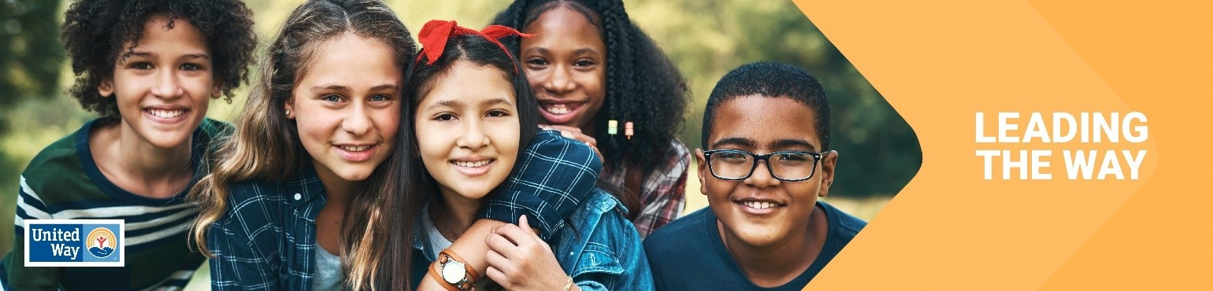
Click here for the Canva template

Subject Line: What are we doing together in Portland and Southwest Washington?
Preheader Text: Mobilizing our community and changing lives.

Email Body:

Hi [Name],
We need you with us-- whether you’re new to United Way of the Columbia-Willamette or you’ve been creating impact with us for years.
At United Way, we believe that everyone who lives and works in Portland and Southwest Washington deserves the opportunity to thrive. Together with you and partners like [Company Name], United Way mobilizes the caring power of people to create transformational change in our communities.
Day in and day out, our local United Way develops and leads programs that meet the most urgent needs in our community, which includes Clackamas, Clark, Multnomah and Washington counties. We’re proud of all we’ve accomplished together for our great community:
Our Multnomah and Washington County Early Learning hubs are dedicated to amplifying the voices of families who have historically faced inequities based on factors such as race, income, zip code or language. By forging partnerships among organizations, parents and communities, we strive to create an inclusive education ecosystem that supports families in raising resilient, healthy children who are lifelong learners. We believe every child can be successful in school.
More work is needed to build on this momentum. If you’ve already given, thank you. If you haven’t, there’s still time to join in.
BUTTON TEXT: Donate [[if your campaign uses online giving, place the link provided by your UWCW contact here]
Together, let’s Lead the Way and make great things for people who call Portland and Southwest Washington home.
[Closing],
Signature

Email 3b: Reminder #2
From: Your United Way CEO/CPO, Board or Campaign Chair’s first and last name
Audience: All company employees
Call to Action: Join the campaign by donating

Image: Use below, select one of your own images, select an image from the United Way of the Columbia-Willamette Campaign Photo Kit.
Click here for the Canva template

Subject Line: How United Way and [Company Name] are Leading the Way
Preheader Text: Partnered up to create real impact
Email Body:

Dear [Name],
We want to take a moment to celebrate how United Way of the Columbia-Willamette and [Company Name] are partnering to change lives in our community.

Thanks to [Company Name]’s support and people like you…
[This email should be tailored to your relationship with the company. We suggest:
Highlight the number of years a company has been a sponsor
Highlight the impact the company has had during your day of action/day of caring—the # of hours, the value of that volunteer service to the community. How United Way has helped deepen the company culture around service. Add photos from Day of Action/Caring, if you have releases.
Has the company done food drives or holiday drives through united way to benefit the community?
Does the company have a number of hours of volunteerism to celebrate?]
Let’s build on [Company Name]’s legacy to do even more. Donate today to Lead the Way to a better future for Portland and Southwest Washington!

BUTTON TEXT: Donate [[if your campaign uses online giving, place the link provided by your UWCW contact here]
[Closing],
Signature

Email 3c: Reminder #3 or Final Reminder
From: Your United Way CEO/CPO, Board or Campaign Chair’s first and last name
Audience: All company employees
Call to Action: Join the campaign by donating

Image: Use below, select one of your own images, select an image from the United Way of the Columbia-Willamette Campaign Photo Kit.
Click here for the Canva template

Subject Line: Time is running out to Lead the Way
Preheader Text: Tick, tock…
Email Body:

Have you donated yet to Lead the Way in Portland and Southwest Washington?

From strengthening local resilience to advancing health, youth opportunity, and financial security, your support is integral to creating impact in our community. Employees at [Company Name] are chipping in and Leading the Way to a better future for everyone in Portland and Southwest Washington!
BUTTON TEXT: Donate [if your campaign uses online giving, place the link provided by your UWCW contact here]
Thank you for your continued support!
[Name],
[Closing],
Signature

Email 4a: General Thank You #1
From: Your United Way CEO/CPO, Board or Campaign Chair’s first and last name
Audience: All company employees
Call to Action: See your impact

Image: Use below, select one of your own images, select an image from the United Way of the Columbia-Willamette Campaign Photo Kit.
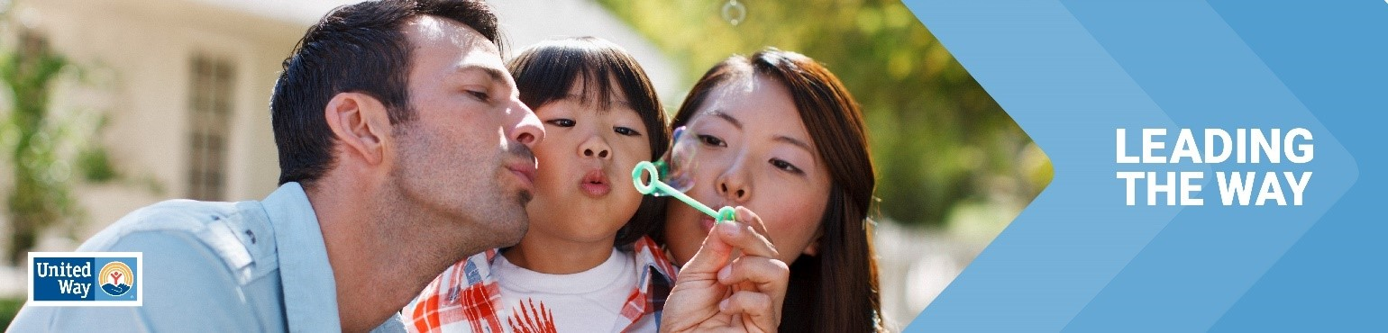
Click here for the Canva template

Subject Line: Thank you for Leading the Way in Portland and Southwest Washington!
Preheader Text: [intentionally left blank]
Email Body:

Dear [Name],

Join me in celebrating the success of [Company Name’s] efforts to Lead the Way by changing lives in Portland and Southwest Washington.

I’m thrilled to report: [customize]

[Company Name] employees gave $ [dollars pledged] to United Way of the Columbia-Willamette!

[participation rate%] of [Company Name] Employees gave to United Way of the Columbia-Willamette.

[number of donors] of [Company Name] employees gave to United Way of the Columbia-Willamette.

[Company Name] employees contributed more than [number of volunteer hours] volunteer hours during the campaign.

Together, our collective impact is creating a better future for youth, families and communities in Portland and Southwest Washington. Thank you for Leading the Way!
BUTTON TEXT: SEE YOUR IMPACT [Hyperlink]
[Closing],
Signature

Email 4a: Donor Thank You #2
From: Your United Way CEO/CPO, Board or Campaign Chair’s first and last name
Audience: Company employees who donated to United Way (not designated to other organizations)
Call to Action: Continue your support

Image: Use below, select one of your own images, select an image from the United Way of the Columbia-Willamette Campaign Photo Kit.
Click here for the Canva template

Subject Line: Thank you for Leading the Way in Portland and Southwest Washington!
Preheader Text: [intentionally left blank]
Email Body:
Dear [Name],
First, thank you for Leading the Way in Portland and Southwest Washington through your generous gift to United Way. Your donation is making a real difference in the lives of our neighbors and friends.
Today and every day, we need you with us. Here are ways that your support can continue making our community a better place:
  - Volunteer: Make a difference by volunteering – providing a ride to someone who’s homebound, reading to preschoolers to get them school-ready, or passing out food to neighbors in need. Consider serving on one of our community’s grant evaluation boards or offering your unique skills to a local nonprofit who needs your expertise. See a myriad of volunteer opportunities at United Way’s Hands On Greater Portland website: https://www.handsonportland.org/
  - Advocate: Encourage your neighbors and colleagues to become active in our community and raise your voice on the issues that impact hard-working families in Portland and Southwest Washington. Join United Way’s in-person and virtual events to help every person in our region thrive.
  - Stay in the Loop: Signup for our email newsletter to keep informed about what’s going on across Portland and Southwest Washington. Sign up on our website here: https://www.unitedway-pdx.org/
Thank you for your commitment to United Way of the Columbia-Willamette. Together, let’s Lead the Way to a better future for all.
[Closing],
Signature

